


  Google For Education with |   
教學手冊


   | 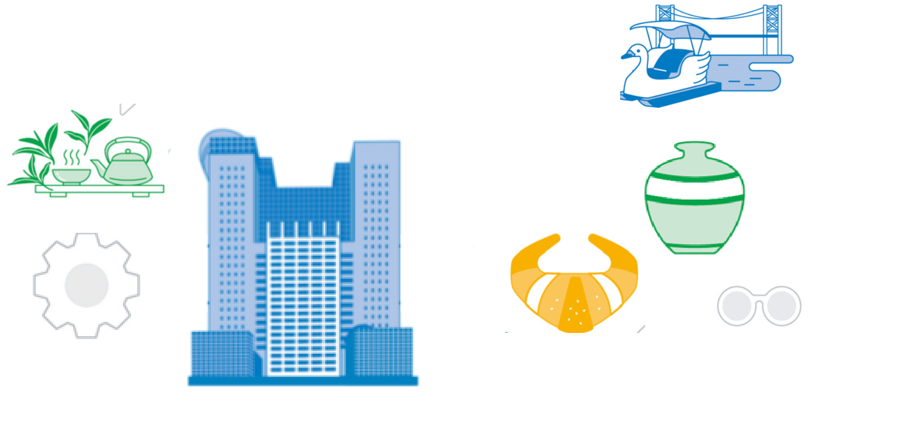



目次
序一：攜手Gemini AI，共創智慧學習新世代.............................................1序二：這是一份手冊，也是一份邀請..........................................................2 1. 第一篇：從Gemini開始-與Google AI教育同行.....................................3 1.1. 課前運用Gemini........................................................................... 5 1.2. 課中運用Gemini......................................................................... 12 1.3. 課後運用Gemini......................................................................... 20 2. 第二篇：NotebookLM-你的第二個大腦.............................................. 25 2.1. NotebookLM的「登入」與「來源」.................................................26 2.2. NotebookLM的「筆記本導覽」.................................................... 30 2.3. NotebookLM的「查看對話」與「命令提示列」...............................37 2.4. NotebookLM的「分享」............................................................... 40 3. 第三篇：Google Classroom 智慧新功能........................................... 43 3.1. 「學生分組」功能讓適性化學習更輕鬆......................................... 43 3.2. 「練習題」(Practice Sets)設計讓教材更智慧...............................46 3.3. 「內置題目」讓影片學習更有效果.................................................54 3.4. 「ReadAlong」一位永遠陪伴你的AI多語老師..............................60 3.5. 「評分週期功能」(Grading Periods)讓你成績不混淆.................. 64 3.6. 「原創性報告」快速幫助老師作業檢核......................................... 66 3.7. 「分享課堂功能」讓數位備課共享更簡單......................................69 4. 第四篇：新功能讓你更靈活For Education......................................... 72 1. Google Slides...............................................................................72 2. Google 文件.................................................................................. 76 3. Google Meet................................................................................. 80

